**Exercise 1**

num1=[0 0 10];

den1=[1 2 10];

num2=[0 0 5];

den2=[0 1 5];

[numA,denA]=series(num1,den1,num2,den2);

[numB,denB]=parallel(num1,den1,num2,den2);

[numC,denC]=feedback(num1,den1,num2,den2);

[numD,denD]=cloop(num1,den1,-1);

sysA=tf(numA,denA)

sysB=tf(numB,denB)

sysC=tf(numC,denC)

sysD=tf(numD,denD)

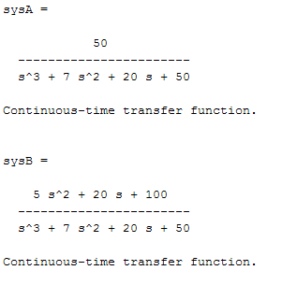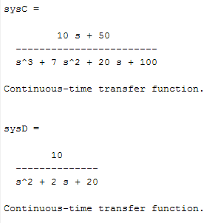

**Exercise 2**

num1=[0 0 4];

den1=[0 0 1];

num2=[0 0 1];

den2=[0 1 2];

[num,den]=series(num1,den1,num2,den2);

num3=[0 5 0];

den3=[0 0 1];

[numa,denum]=feedback(num,den,num3,den3);

sys=tf(numa,denum)

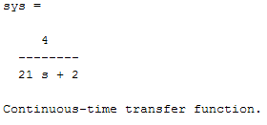

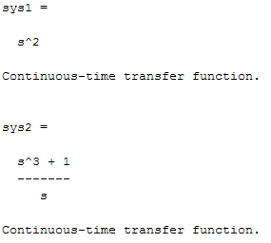**Exercise** **3**

num1=[0 1 0];

den1=[0 0 1];

num2=[0 1 0];

den2=[0 0 1];

[num3,den3]=series(num1,den1,num2,den2);

sys1=tf(num3,den3)

num4=[0 0 1];

den4=[0 1 0];

[num5,den5]=parallel(num3,den3,num4,den4);

sys2=tf(num5,den5)

[num6,den6]=cloop(num5,den5,-1);

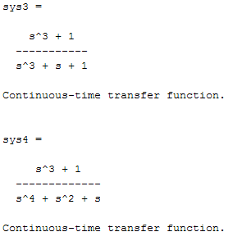sys3=tf(num6,den6)

num7=[0 0 1];

den7=[0 1 0];

[num8,den8]=series(num6,den6,num7,den7);

sys4=tf(num8,den8)

num9=[0 1 0];

den9=[0 0 1];

[num,den]=feedback(num8,den8,num9,den9);

sys=tf(num,den)

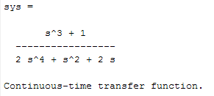

**Exercise 4**

**(b)**

num=[1 7 2];

den=[1 9 26 24];

[A,B,C,D]=tf2ss(num,den)

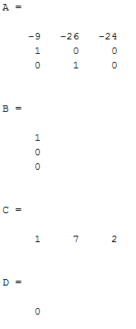

**(a)**

num=[0 1 0];

den=[1 14 56 160];

[A,B,C,D]=tf2ss(num,den)

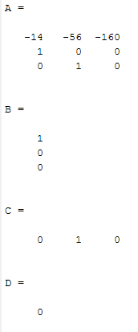

**Exercise 5**

**(a)**

A=[0 1;-6 -5];

B=[0;1];

C=[8 1];

D=[0];

[num,den]=ss2tf(A,B,C,D)

sys=tf(num,den)

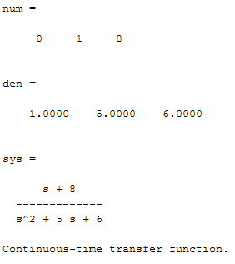

**(b)**

A=[0 1 0;0 0 1;-1 -2 -3];

B=[10;0;0];

C=[1 0 0];

D=[0];

[num,den]=ss2tf(A,B,C,D)

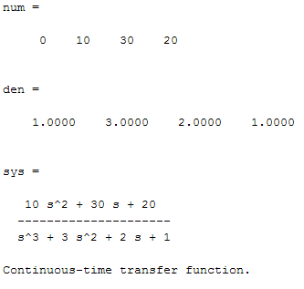sys=tf(num,den)

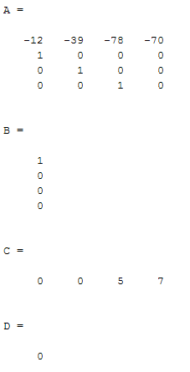**Exercise 6**

num1=[0 5 7];

den1=[0 1 7];

num2=[0 0 1];

den2=[1 5 4 0];

[num3,den3]=series(num1,den1,num2,den2);

sys1=tf(num3,den3)

num4=[0 0 10];

den4=[0 0 1];

[num,den]=feedback(num3,den3,num4,den4);

sys=tf(num,den)

[A,B,C,D]=tf2ss(num,den)

